**Week 8 – Git**

**Git-HOL-1**

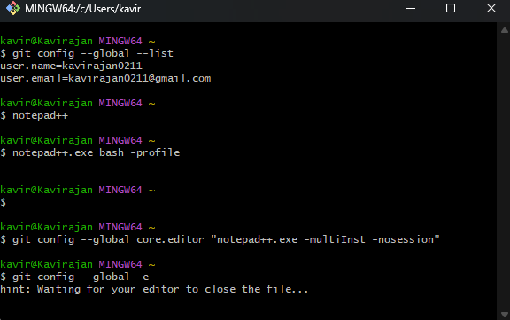

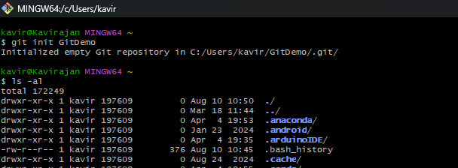

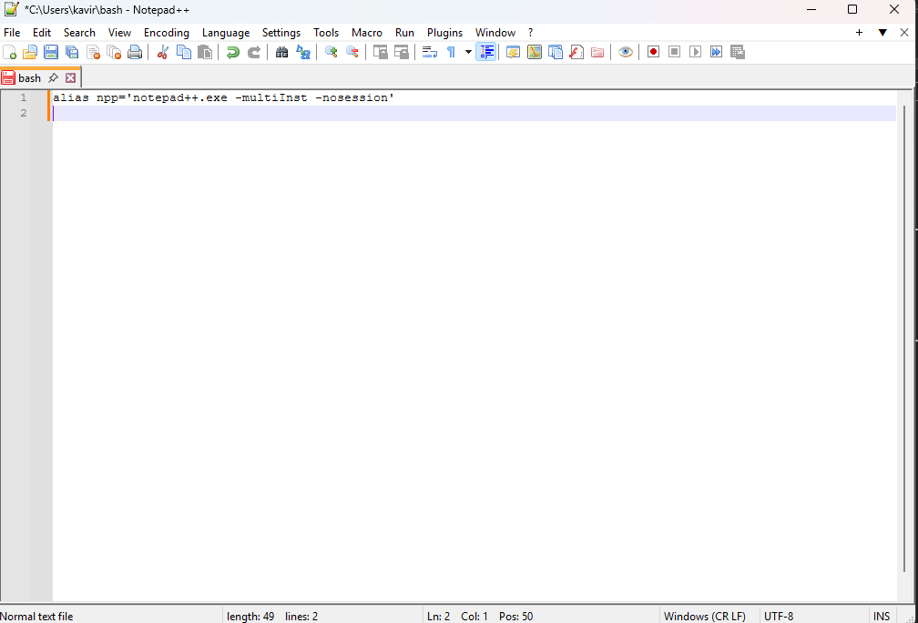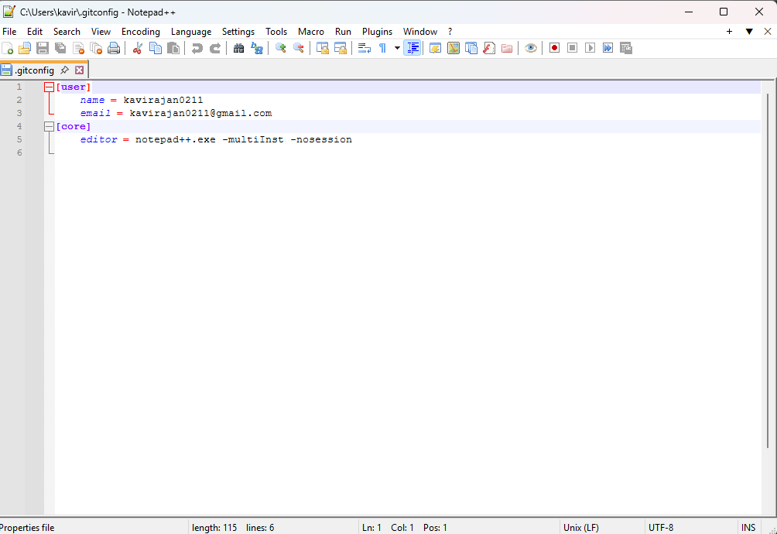

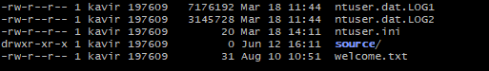



**Git-HOL-2**

**Git Ignore:**

* .gitignore is a special file in a Git project that tells Git which files or folders it should not track.
* For example: temporary files, log files, build files — things you don’t want to upload to the online repo.

**How to use git ignore:**

1. *.log - ignore all .log files
2. temp/ - ignore the temp folder
3. welcome.txt - ignore a single file

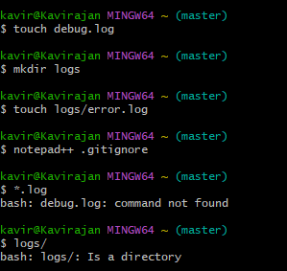

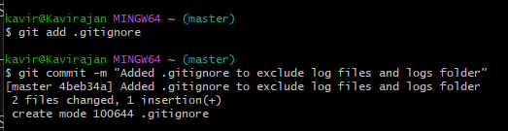

**Git-HOL-3**

**Branching:**

* Creating a copy of your project where you can work on changes without affecting the main code.

**Merging:**

* Once branch changes are ready, combine branch back into the main branch (usually master).

**Branch request in GitLab:**

* Creating a new branch in the repository to work on your changes.
* It can be achieved by git branch GitWork → git push origin GitWork.

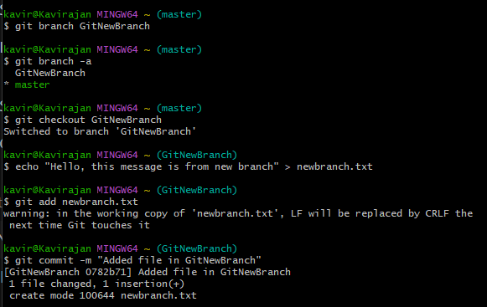

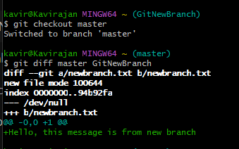

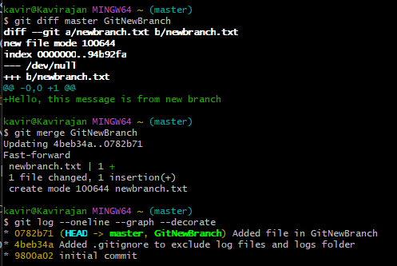

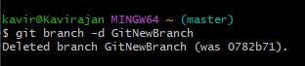

**Git- HOL-4**

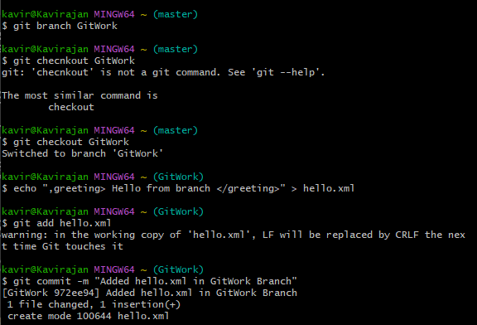

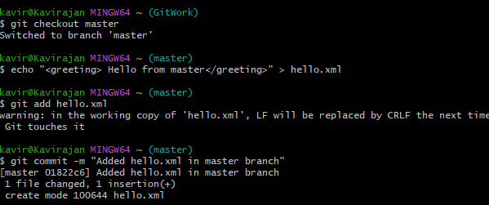

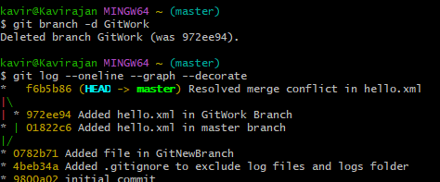

**Git-HOL-5**

**Cleanup and push in Git:**

* Make sure your work is saved → commit your changes in Git.
* Check you’re connected to the online repo (GitHub/GitLab).
* Get the latest version from the online repo so you don’t overwrite someone else’s work (git pull).
* Send your changes to the online repo (git push).